
Adjustable Upper Control Arm
Part No. 94356 UPC# 082642943563

4045 Specialty Place • Longmont, CO 80504 • 800-525-6505 • 303-772-2103 • Fax 303-772-1918 • www.specprod.com

Part No. | Jobber | List
94356 | 359.06 | 478.75

All pricing in US Dollars • ©2017 Niwot Corp. dba Specialty Products Company®

SSAVE OVER

50%
January 12, 2017

Press Release/New Product

Adjustable Upper Control Arm
Part No. 94356

Give your 1965-70 Impala, Bel Air, Caprice or Biscayne a more modern alignment set-up with SPC's adjustable front upper control arm. This highly adjustable A-arm provides ±3° of caster and ±3° of camber compared to the OE arm. Install SPC adjustable control arms and dial in camber and caster for better return to center, improved high-speed stability, and an improved camber curve. The arm is constructed with a high strength chromoly steel cross shaft and includes bonded rubber OE style bushings with minimal deflection for precise handling and just enough damping of road harshness. This arm comes with an extended length ball joint and spacer plate to ensure an out-of-the box fit. Looking for pro touring handling characteristics? Customize your arm to your driving style by getting low friction greaseable pivots with Delrin sleeves #92025. Kits are sold per arm.
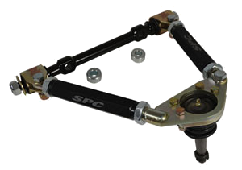
Front Adjustment range: Camber±3.00° Caster ±3.00° Installation time: .7 hr/side
Required: 1 kit per wheel
Applications:
Chevrolet: 1965 - 70 Belair, Biscayne, Caprice, Impala

