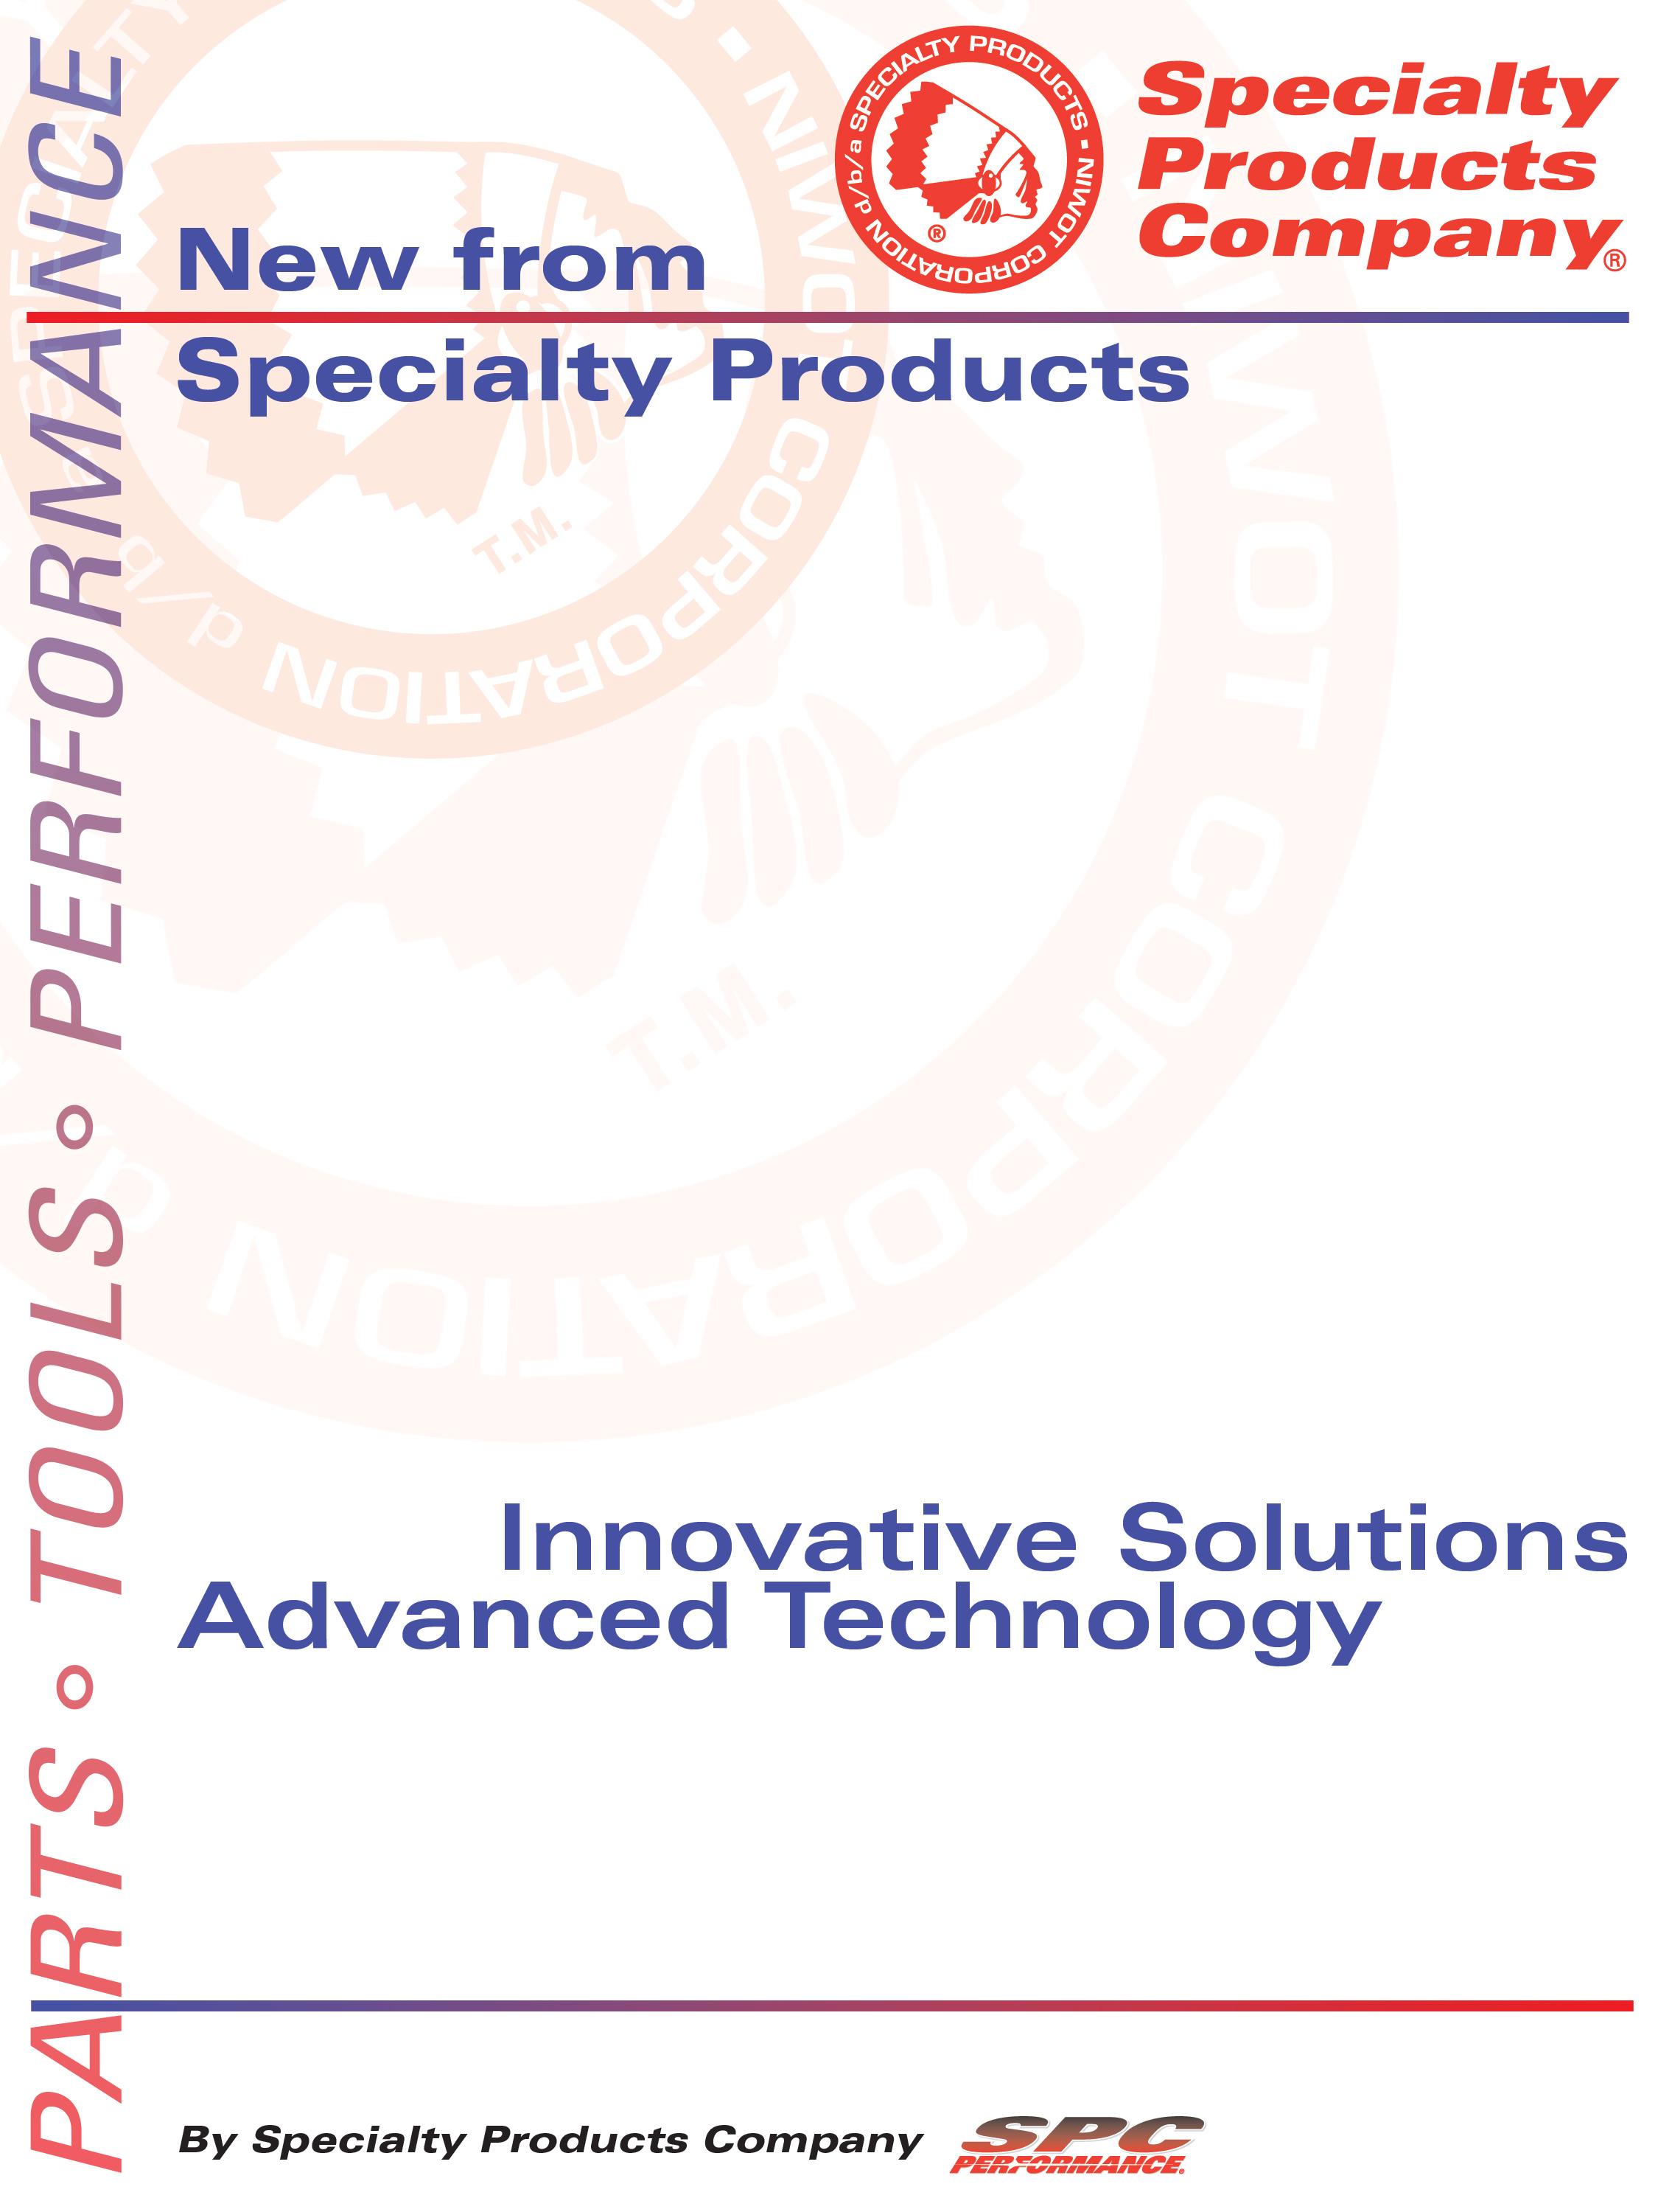
Drum Silencer
Part No. 00085 UPC# 082642000853

4045 Specialty Place • Longmont, CO 80504 • 800-525-6505 • 303-772-2103 • Fax 303-772-1918 • www.specprod.com

Part No. | Jobber | List
00085 | 43.42 | 54.27

All pricing in US Dollars • ©2017 Niwot Corp. dba Specialty Products Company®

SSAVE OVER

50%
January 12, 2017

Press Release/New Product

Drum Silencer
Part No. 00085

00085 is a heavy duty brake lathe silencer for use on truck drums.
DIMENSIONS: 2-3/4" wide, 72" long

